Sing a song for Christmas, you’ll believe it if you try  4 and 20 reindeer, flashing through the sky  When the song was started, the elves began to sing  Wasn’t that a lovely way to start us chuckling?  The world is unravelling  So a spaceman came travelling  And released a white dove  To show the power of love  Peace and goodwill to all | 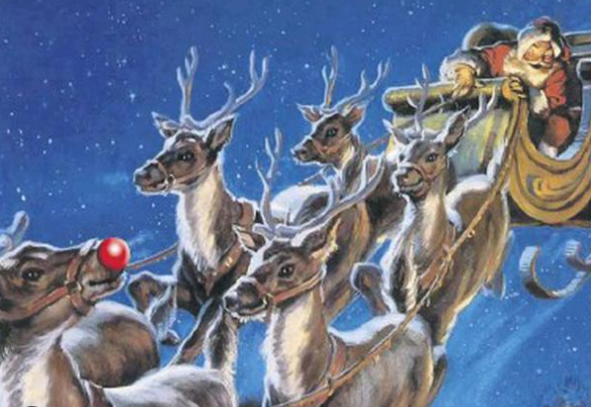  Stop the cavalry! Bring mistletoe and wine  I’m dreaming of a white Christmas, so we’ll be fine
 | The Pretenders will go 2000 miles  The folk on the street are all smiles  Cos Santa Claus is comin’ to town  Let it snow, let it snow, let it snow,  Put on a great Christmas show  Frosty the snowman, walking in the air  Little drummer boy, does he care..  If I believe in Father Christmas?  In the bleak midwinter, the first Noel,  Good king Wenceslas casts his spell
Listen to the fairy tale of New York
Sit by the fire, drink mulled wine and talk
But do they know it’s Christmas?
Winter wonderland, look up and cheer  It’s Rudolph the red-nosed reindeer..  Driving home for Christmas, so make yourself free  Rockin’ around the Christmas tree  Cos it’s Christmas (baby please come home)  I wish it could be Christmas everyday  Get up and sing, that’s the way  Angels have fun, and you can too  But all I want for Christmas is you  So have yourself a merry little Christmas  Merry Xmas everybody | 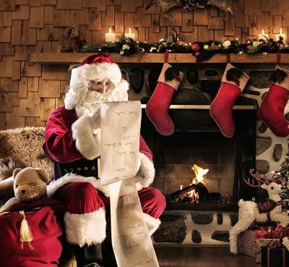
So how many songs, who first sang them and in what year?

Answer Sheet
27 Songs
A Spaceman came Travelling  The Power of Love  Stop the Cavalry  Mistletoe and Wine  I’m Dreaming of a White Christmas  2000 Miles  Santa Claus Is Comin’ to Town  Let it snow, Let it snow, Let it snow,  Frosty the Snowman  Walking in the Air  Little Drummer Boy  I believe in Father Christmas  In the bleak midwinter  The First Noel  Good King Wenceslas  Fairytale of New York  Do they know it’s Christmas?  Winter Wonderland  Rudolph The Red-Nosed Reindeer  Driving Home for Christmas  Rockin’ around the Christmas tree  Christmas (Baby Please Come Home)  I Wish It Could Be Christmas Everyday  Angels  All I Want for Christmas Is You  Have yourself a merry little Christmas  Merry Xmas Everybody | Chris de Burgh (1975)  Frankie Goes to Hollywood (1984)  Jona Lewie (1980)  Cliff (1988)  Bing (1942)  Pretenders (1983)  Harry Reser (1934)  Vaughan Munroe (1945)  Gene Autry and the Cass County Boys (1950)  Aled Jones (1985)  The Trapp family (1951)  Greg Lake (1974)  Set to music by Gustav Holst (1906)  Arranged and Pub. By John Stainer (1871)  Arranged and Pub. By John Neale (1853)  The Pogues (1985)  Band Aid (Bob Geldorf & Midge Ure) (1984)  Richard Himber (1934)  Harry Brannon (1949)  Chris Rea (1986)  Brenda lee (1958)  Darlene Love (1963)  Wizzard (1973)  Robbie (1997)  Mariah Carey (2011)  Judy Garland (1944)  Slade (1973)

